Hexaware-rejected

Acty-rejected

TCS-rejected

Zeus-rejected

TSS-rejected

Tech Mahindra

Capgemini

Vodafone

Merkle-rejected

HFFC-

Shell-

Decimal point-

Exponentia-

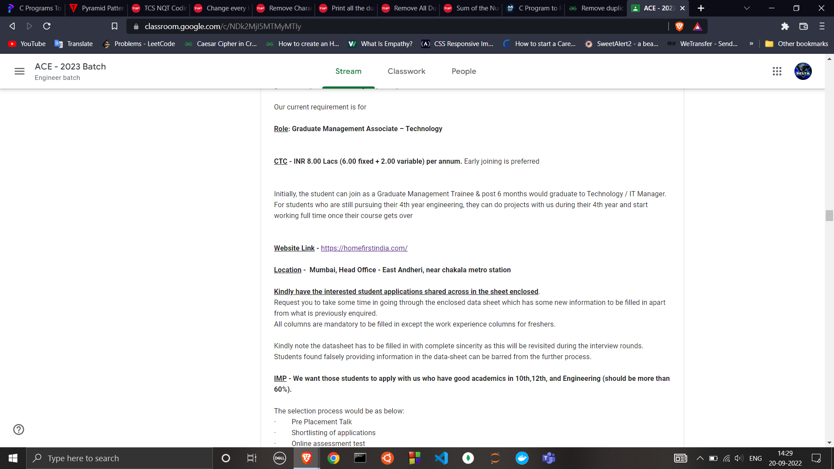

HFFC

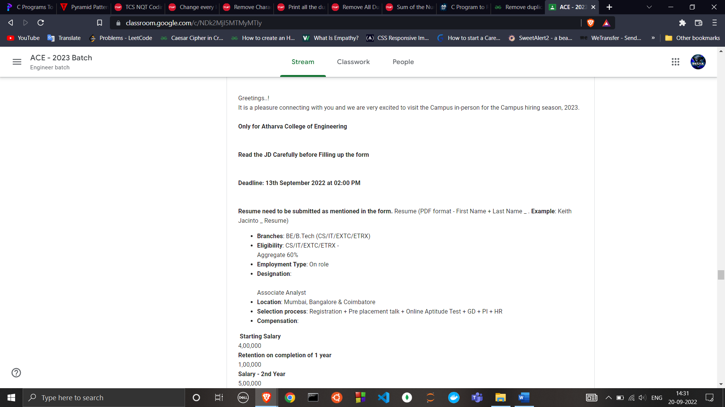

Merkle

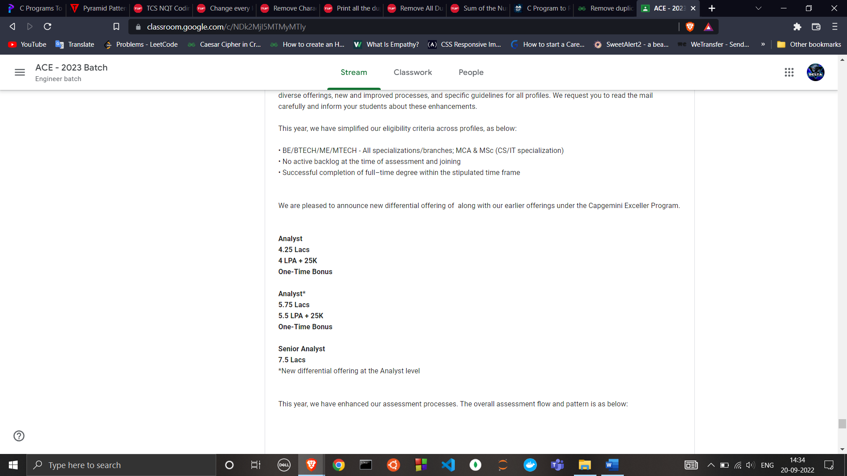

Capgemini

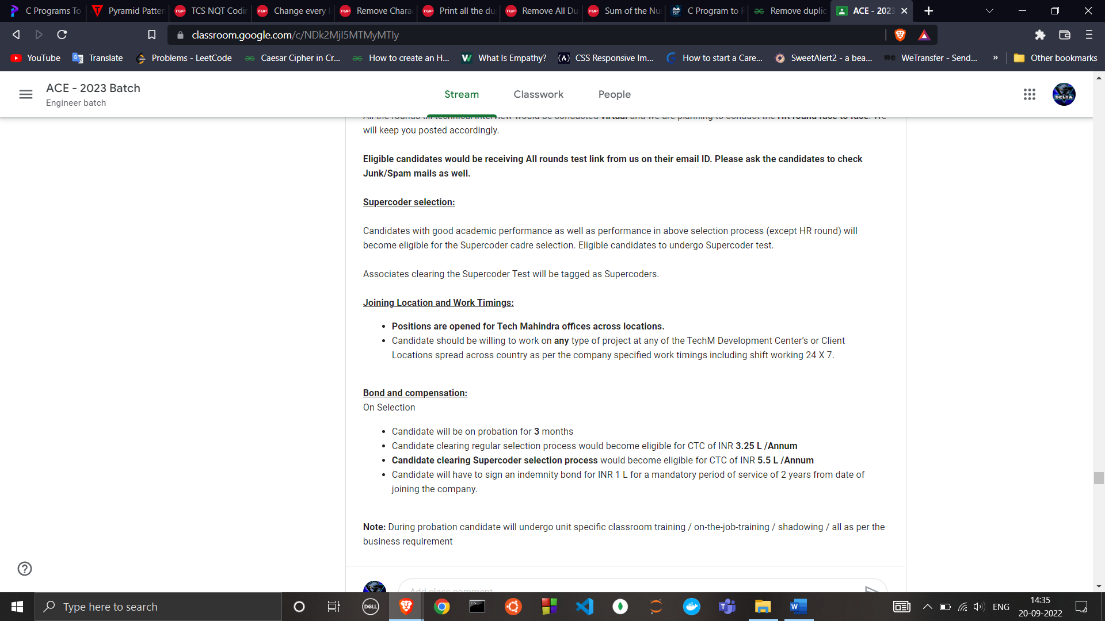

Tech Mahindra

Decimal Point

